Module 4 Challenge ReadMe

By: Monica M. Holmes

3/17/2021

Deliverables:

Deliverable 1:

The first deliverable was to take the student_data_df and replace the ninth-grade reading and math scores, with NaN’s. The data started out looking like image 1, below and the final output looked like image 2, below.

Details of the deliverable:

I utilized the Loc method to select all the ninth-grade reading and math scores at Thomas High School, by extracting the “school_name” column from the “student_data_df” then retrieved all the rows with the ninth grade from the “grade”column of the “student_data_df”, then changed both the reading and math scores, separately, from their respective column names, “reading_score” and “math_score”, then set the ninth-grade reading and math scores from Thomas High School to be replaced by NaN.

Image 1:

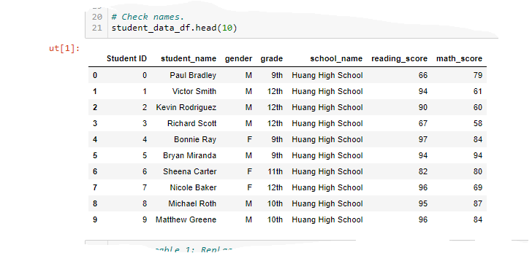

Image 2: 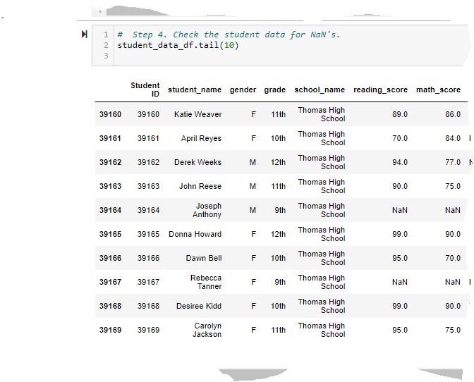

Deliverable #2:

This is how the District Summary looked before removing the Thomas High School, 9th grade reading and math scores:

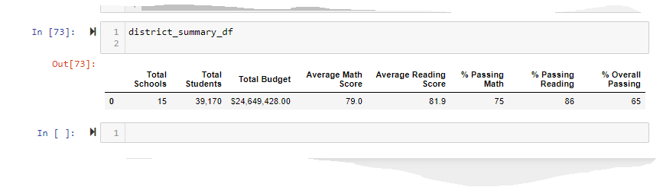

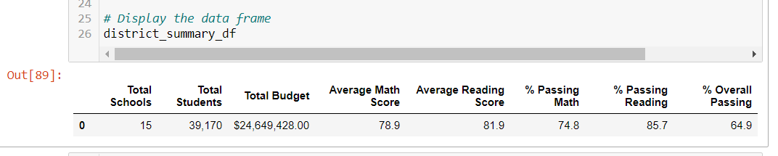

This is the latest “per school summary. df” screen shot with updated Thomas High School information:

